Parys Technografx Ltd

PTvncSWM5 Manual

Table of Contents

PTeSVNC (for the PC)

Installing …………………………………………………………… 1

WinVNC …………………………………………………………… 2
VNCviewer …………………………………………………………… 3

PTvncSWM5 (for Window’s Smartphones 2003, 2003SE, WM5.x)

Installing …………………………………………………………… 4
Connecting …………………………………………………………… 5
Button Usage ………………………………………………………… 6
Options …………………………………………………………… 7
Connection Settings …………………………………………… 9
NetStats …………………………………………………………… 11
Keyboard …………………………………………………………… 12
Smartphone Keyboard …………………………………………… 13
Zoom …………………………………………………………… 14
Magnify …………………………………………………………… 15
File Transfer …………………………………………………… 16
Encodings/Settings …………………………………………… 19

Support ………………………………………………………..…. 21

Installing PTeSVNC

Installing PTeSVNC
(Note that you can connect PTvncSWM5 to other versions of VNC instead)

PTeSVNC is Parys Technografx’ VNC server and client software for the PC.
The installer file is “SetUpPTeSVNC.exe”.

To install PTeSVNC on your PC you need to run “SetUpPTeSVNC.exe”, the installer will install PTeSVNC to a destination of your choice.

Once installed, in order to connect to your Smartphone you must have PTvncSWM5 installed on your Smartphone, run the WinVNC server program with a valid TCP/IP connection (eg. WiFi, Bluetooth or via the Internet) available from your Smartphone to your PC and then run PTvncSWM5 on your Smartphone.

NB. PTvncSWM5 is also compatible with versions of RealVNC, TightVNC, UltraVNC, eSVNC etc.

Note that when you first run WinVNC on your PC you should supply a suitable password to allow client software (such as PTvncSWM5) to connect to your PC.

On some systems you may need to go into the advanced options in WinVNC and enable loopback connections in order to connect to PTvncSWM5 (try this if you’re sure you’re using the correct password but PTvncSWM5 returns “authentication failed” when trying to connect).

If you decide to install WinVNC on your PC as a service then remember to supply the service version with a password (this is stored separately from when WinVNC is run “normally”).

If connecting to RealVNC or TightVNC (or other versions of WinVNC without compatible server scaling) then you must select the “Scaling off” option on the password entry screen in PTvncSWM5.
Also if connecting to versions of RealVNC (or some of the other alternative VNC servers) then the “Tight” and maybe other encodings will be ignored by WinVNC and “RAW” used instead so you should change the encoding type to one compatible with the VNC server (e.g. “Hextile”) by going to the Connection Settings on the hostname entry screen in PTvncSWM5 (by pressing “home”).

If you decide to use UltraVNC instead of PTeSVNC then when making changes to the connection settings from the connection options in PTvncSWM5 you must select "Reconnect" or "New connection" as "Apply changes" will not work correctly.

WinVNC

WinVNC is VNC server software for the PC. It allows compatible VNC client software to connect to, view (and control) your PC when it is running.

When you first run WinVNC you need to supply a password that will be required from any VNC client software trying to connect to your machine.
The configuration menu that appears when you first run the program (below) can also be accessed any time WinVNC is running by either right-clicking on the WinVNC icon on your taskbar and selecting Properties, or by selecting Programs : PTeSVNC : Server : WinVNC User Settings from your Start menu.
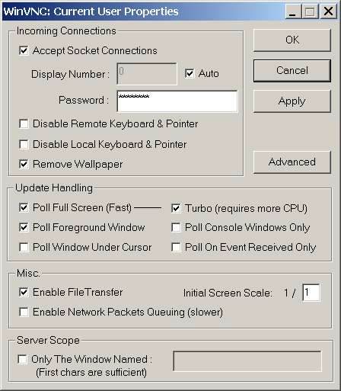
The important things to note are that you can set WinVNC to allow a client to connect and view your PC but without having remote control of your PC’s mouse and keyboard, you may also disable the PC’s own mouse and keyboard allowing ONLY remote control. The remove wallpaper option will do exactly that when any connection is made, this makes transfer much faster when the PC’s desktop is in view. The Update Handling settings shown are the ones I would recommend except that it’s worth enabling “Poll Console Windows Only” for many uses as most Windows software will still be viewed on the remote machine.
Note that you may also disable File Transfer.
On some systems you may need to “enable loopback” in the Advanced section to connect to PTvncSWM5 (also here, logging could be useful if you have problems).
To close WinVNC when it’s running right-click on the WinVNC icon on your taskbar and select close from the menu.
If you wish you may set up WinVNC as a service, if you do so WinVNC will be running each time you boot up your PC. To set WinVNC as a service go to Programs : PTeSVNC : Server : Install WinVNC Service from your Start menu (you will find the remove service here also). It is best to reboot your PC after installation.
In the advanced section there is an option to lock your PC when a client disconnects, note that if this is enabled and the PC becomes locked after disconnection then you will only be able to reconnect if WinVNC is running as a service.
Note that after a cold boot of a PC that requires initial logon you won’t be able to connect via VNC before initial logon even using the service version of WinVNC.

VNCviewer

The VNCviewer provided with PTeSVNC is the VNCviewer from eSVNC 112r2.
VNCviewer is VNC client software for the PC that allows a remote PC to connect/control another PC running the PTeSVNC WinVNC server.

As with PTvncSWM5 you can control your connection settings from the options in VNCviewer:

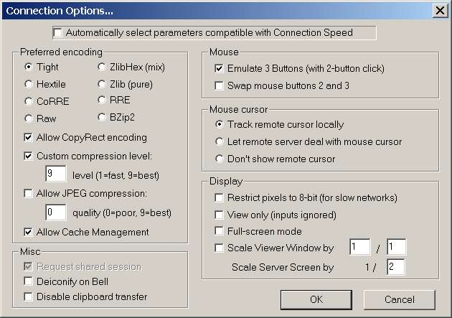
Note that in order to configure your settings manually you must first disable “Automatically select parameters compatible with Connection Speed” as above.
See the section about PTvncSWM5 for more help regarding the connection settings.
Note also that in the VNCviewer once you have made changes you may need to select “Request screen refresh” from the menu for changes to become apparent.

Installing PTvncSWM5

PTvncSWM5 is Parys Technografx’ VNC client software for the Window’s Smartphones (2003, 2003SE and WM5.x).
The installer file is “InstallPTvncSWM5.exe”.

To install PTvncSWM5 to your Smartphone you need to connect your Smartphone to your PC via ActiveSync and then run “InstallPTvncSWM5.exe” on your PC.

After retrieving information from your Smartphone the installer will allow you the option of installing to the default download location (Program Files in your normal Smartphone memory) or to select an alternative location e.g. a storage card.

Simply follow the instructions on PC and Smartphone to install.

Once installed, in order to connect to your PC you must have PTeSVNC (or other VNC software) installed on your PC, have the WinVNC server program running and ready to accept connections, and of course a valid TCP/IP connection available from your Smartphone to your PC.

Note that to connect over Bluetooth or over USB then Activesync must be running over the connection for the VNC connection to be made – this is not required over GPRS/CDMA or WiFi.

NB. PTvncSWM5 will connect successfully to versions of eSVNC, PTeSVNC or UltraVNC AND RealVNC and TightVNC.
Note that for WinVNC servers that do not have compatible server scaling (eg. RealVNC or TightVNC) then you must use the joypad to select “Scaling off” on the password entry screen in PTvncSWM5 (see next page).
Also if connecting to WinVNC servers that do not support the “Tight” encoding then for optimum performance you should change the encoding type to the best method compatible with your VNC server (“Hextile” is usually compatible) by going to the Connection Settings on the hostname entry screen in PTvncSWM5 (by pressing “home” – see next page).

If you decide to use UltraVNC instead of PTeSVNC then when making changes to the connection settings from the connection options in PTvncSWM5 you must select "Reconnect" or "New connection" as "Apply changes" will not work correctly.

To uninstall PTvncSWM5 from your Smartphone go to Settings : Remove Programs and select “Parys Technografx PTvncSWM5” from the list of installed software.
Connecting PTvncSWM5 to PTeSVNC
First of all a server (eg. WinVNC from PTeSVNC) needs to be installed and running on your PC (see pages 1 and 2) and you must have a valid TCP/IP connection from your PC to your Smartphone (this could be WiFi, Bluetooth or a remote Internet connection).
Secondly you need to know either the network name of the server PC or its IP address and the password that was given to WinVNC to allow connection.
Now you can run PTvncSWM5, enter the host (server) name or IP address (optionally plus port number) and then the password to connect to WinVNC.
NB. The default port used is 5900, specifying a port number from 0 to 9 will use a port from 5900 to 5909, specifying a port number 10+ will use that exact port number.
Once connected you will view a section of your PC’s screen on your Smartphone and (optionally in WinVNC) have control over the PC’s mouse and keyboard from your Smartphone plus (optionally in WinVNC) be able to transfer files between PC and Smartphone.
Entering the host (server) name/IP (and optional port)
When you run PTvncSWM5 you will be presented with a screen to enter the host name or IP address eg. “dave” or “192.168.0.1” (if you wish you can specify a port as well eg. “dave:1” or “192.168.0.1:80”). To type in the text just use your buttons guided by the graphical keyboard (see below left). See page 13 for more instructions on the keyboard.
Note that joypad centre is the button used for enter/return and back for backspace.
The joypad directions choose between Remote (gprs) or local (Bluetooth/WiFi) connection. It should be noted that if you opt for a Bluetooth/WiFi connection then any current open connection to GPRS or CDMA (eg. from when browsing or downloading) will be disconnected.
If there are previously saved connections then you can press “make call” to choose one.
You can press “home” to set the initial connection options, note that some encodings (eg. “Tight”) are not supported by RealVNC (see page 9 for more info).

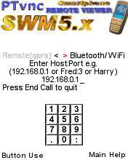
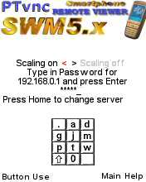

When you’ve entered the host (:port) the password entry screen will appear for you to give the appropriate password (see above right).
On both the hostname and password entry screens you can press the left menu button for quick help (on button use when connected) or the right menu button for full help.
If a host name is used rather than an IP address then the IP address found for the given name is displayed on the password screen (this gives you some idea whether your router located the correct machine or not).
On the password entry screen you can use the joypad directions to choose whether to use server scaling or not. Note that some versions of WinVNC (eg. “Real”VNC or TightVNC) do not support server-scaling and to connect to these you must choose the “Scaling off” option (using the joypad).
Again simply use your buttons guided by the graphical keyboard to enter the password.
After entering the password the following screen will appear:

After a few seconds connection should be made and your PC’s screen appear on your Smartphone. If it takes longer than a minute or so for this to happen using Bluetooth or WiFi, or longer than 2 or 3 minutes using GPRS or CDMA then press your “back” button and check that you got the host(:port) and password correct.
If you’re sure you have the host(:port) and password correct and have repeated the procedure two or three times without success, then exit PTvncSWM5 and re-run it to try again.
Please note that VNC servers from some versions of VNC are not compatible with PTvncSWM5 so if you have tried everything suggested in this help file (see the support section at the end) and are still unable to connect then try using a different VNC server (such as PTeSVNC or UltraVNC) instead of the version you are currently using e.g. PTvncWM5 definitely works with UltraVNC v1.0.0 rc11d, RealVNC 3.3.7 and TightVNC 1.2.9 as well as the included version of PTeSVNC.

Once your PC’s screen appears on your Smartphone you can send left or right mouse clicks to the PC by pressing the left and right menu buttons on your Smartphone so you can run programs etc. If you seem to have a problem with double-clicking the button to run programs then simply reduce the double-click speed on the server system.
The Smartphone can only read one button at a time so if you wish to “click-and-drag” (eg. resizing window, moving icon etc.) then click and hold the appropriate button (for left or right PC mouse button) until a hand appears on top of the PC cursor, then release the “mouse” button and you can use the joypad directions to “drag”. To release the held down PC mouse button simply press the left or right menu button once again.
Move the cursor using the joypad directions, when you reach the edge of the display the view will scroll around your PC’s screen.
Use the joypad centre button as “enter” when inputting text or to send an “enter” keypress to the server.
When not in full keyboard mode, pressing “home”, “back” or one of the other buttons (0-9, # or *) will enter Smartphone keyboard mode (see page 13).
Note that once connected your “Make Call” button is the button to bring up the PTvncSWM5 Options and the “End Call” button will quit the program.
When in the file transfer sections, you must exit file transfer before you can quit the program.
The Options menu

When you press the Options button (make call) a screen below will appear:

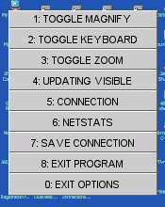
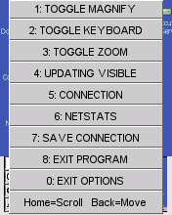

The menu above right will appear when the small full-screen view of your PC is visible and you may press “Home” to fast-scroll or “Back” to fast-move. Both are basically the same. A cursor will appear in the full-screen view - use the joypad directions to move it around. In fast-scroll mode the main view also scrolls as you move, the left menu button works normally and the right menu button exits the mode. In fast-move mode the main view only changes when you press either menu button to exit the mode. Other buttons function normally in both modes. Fast-move mode is best for reducing bandwidth use.
For the other options press the appropriate button once to select as below:
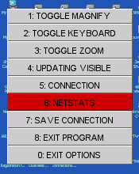

Press the button a second time to execute the option.

Toggle Magnify toggles the optional magnifying glass at the mouse position (in Zoom mode when not using server scaling). See page 15 for more details.
Toggle Keyboard toggles Keyboard mode on and off. See page 12 for more details.
Toggle Zoom toggles Zoom mode on and off. See page 14 for more details.
Updating All/Visible allows you to choose whether changes to areas of your PC screen not currently in view are updated immediately or not. When using Updating Visible such changes will only be updated in the visible area, this can save a lot of bandwidth. Note however that when scrolling around using Updating Visible there may be a slight delay before the view is updated.
Connection takes you to the Connection Settings. See page 9 for more details.
Netstats displays your connection statistics and allows you to set the update delay value that is useful for saving bandwidth when using GPRS or CDMA. See page 11 for more details.
Save Connection allows you to save the current connection (hostname and all settings) with a chosen name for ease of future connection. You could call the connection “Work:Bluetooth” or “Home:GPRS” etc. These connections can be recalled from the hostname entry screen by pressing “Make Call” next time you are making a new connection (i.e. on the hostname entry screen).
Exit program, well, exits the program.
Cancel simply removes the Options menu.
It’s worth noting that if the Options menu is displayed then pressing the Options button will take you directly to the Connection Settings menu.

Connection Settings
The Connections menu (below left) will appear when you press “home” from the hostname entry screen, the full Connection Settings menu (below right) will appear when connected when you either select Connection from the Options menu or press the Options button while the Options menu is displayed:
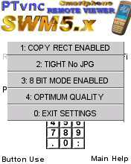
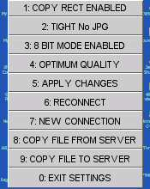

Use the same method to select/change options as for the Options menu i.e. press a button once to select and a second time to apply.
The first option allows you to enable or disable the “Copy Rect” feature of the transfer encodings, selecting this option will toggle between “Copy Rect Enabled” and “Copy Rect Disabled”. (So far I have found no reason to disable this)
The second option (“Tight” above) is the main transfer encoding method. Selecting it will rotate between:
Tight (+JPG option), Zlib, Zlib Hextile, Hextile, CoRRE, RRE and Raw (See page 19).
Note that only Hextile, CoRRE, RRE and RAW are supported by versions of RealVNC and in this case choosing the other options means WinVNC will use RAW encoding so it’s best to set the encoding to Hextile if you wish to connect to RealVNC (See page 19).
The third option allows you to toggle between 8 bit RGB and 16 bit RGB transfer. 8 bit is up to twice as fast but 16 bit provides much better colours. (See page 19). Note that for the Tight JPG options JPG is only used when using 16 bit transfer.
The fourth option allows you to choose between Optimum Speed, Optimum Quality or High Quality. Optimum speed can be up to 4 times faster than Optimum Quality but Optimum Quality is more legible. High Quality is more legible still but costly in terms of speed and bandwidth (See page 19)
If selecting the connection options from the hostname entry screen then simply exit the menu when the settings are as you require.

NOTE THAT FROM THE FULL CONNECTION SETTINGS MENU CHANGES TO THE ABOVE SETTINGS WILL ONLY BE APPLIED AFTER YOU SELECT “APPLY CHANGES”, “RECONNECT” OR “NEW CONNECTION”.
Apply Changes simply applies changes you have made to the settings without disconnecting from the current host.
Reconnect actually disconnects then reconnects to the current host. This option is mainly in case you get a “hung” connection.
New Connection disconnects from the current host and lets you select a new host to connect to.
If using UltraVNC then to apply changes to the connection settings you must select "Reconnect" or "New connection" as "Apply changes" will not work correctly.

Copy File from Server will enter file transfer to copy a file from the server to the Smartphone. (See page 16)
Copy File To Server will enter file transfer to copy a file from the Smartphone to the server. (See page 16)
Cancel turns off the Connection Settings menu (as does pressing the Options button).

Netstats

When you select Netstats from the Options menu, a screen like the one below will appear:
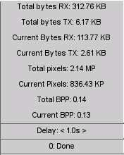

The information is mainly for those of you who are paying per byte downloaded.
You can use the joypad directions to change the delay value.
The delay value lets you specify a delay time for the requesting of updates from the server and larger delay values are useful if you wish to minimise bandwidth use when connected via GPRS or CDMA. If just wanting to use PTvncSWM5 over Bluetooth, WiFi or USB (or indirectly over broadband) then you may wish to use zero delay.
Note that the “Total” values are those from when you ran the program, no matter how many different connections you have made.
The values for bytes received (RX) and bytes transmitted (TX) include the amounts used for file transfer, however the bytes received figure used internally to calculate the Bytes per pixel does not include bytes received during file transfer hence the Bytes per pixel values give an accurate indication of how good your current Connection Settings are at saving bandwidth (tight or zlib seem the best encodings by far from this point of view).
It’s worth noting that when a WinVNC server does not support your current encoding selection then it will switch to sending in “RAW” format – you can check for this by looking at the “Current BPP”, if this value is 1 when in 8-bit mode or 2 when in 16-bit mode then the server is sending raw data and (assuming you’re not using “RAW” anyway) you need to change the selected encoding for optimum performance.
To remove the Netstats just press 0 twice, or press the Options button.

Keyboard mode

When full Keyboard mode is enabled you will see a display as below:

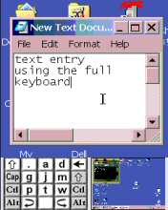

To send key presses to your PC press the appropriate buttons.
Note that joypad centre is used as the “enter” (return) key.
Use the * and # buttons to change the keyboard layout.
Your “Home” button corresponds to left shift (top-left of the graphical keyboard), your “Back” button corresponds to the top-right box of the graphic and is normally used for backspace but note that on one layout it is used as “Escape” and on another as “Numlock”. The remaining boxes in the left and right columns of the graphic do not correspond to buttons, they are simply indicators and light up blue when the corresponding keys are active, ie. Caps lock, Left Control, Left Alt and Right Shift, Right Control, Right Alt.
The central 3*4 block of keys correspond to the keypad on your Smartphone ie. 0 to 9, * and #. The alphabetical layout follows the order normally used on a Smartphone to get these characters NOTE that you change the layout using * and # and NOT by repeatedly pressing an alphabetical character.
The layouts change appropriately when Shift, Caps lock or Num lock are active. Note that the keys like shift and control etc. stay pressed when you press them until you press them a second time.

Smartphone Keyboard mode

When entering text (host:port/password/filename) or when connected and not in full Keyboard mode, text is input using the standard Smartphone method with “abc”, “ABC” and “123” modes available. The difference from standard text entry is how symbols are selected. Press and hold the “#” key to run through the available symbol layouts:



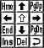

The 4th layout (arrow keys etc.) is only available when sending keypresses to the PC. Hold your “#” button to get the desired layout then press the button for the required symbol, the symbol will be “pressed” and the keyboard layout will revert back to “ABC”, “abc” or “123” format. If you enter symbol mode and wish to exit without pressing a symbol then use the “back” button. When sending keypresses to the PC in the 4th layout (arrow keys etc.) the keyboard will stay in that layout until you change it or exit symbol mode.
When connected you can use “Home” to toggle Smartphone keyboard entry, or if the Smartphone is not currently visible then pressing any keyboard button will enable it.
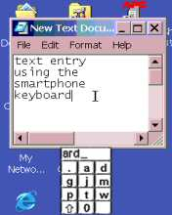
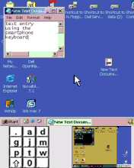

As above a text bar is shown when typing to the PC so you know what keys you have pressed - this is required as keys pressed are not sent to the PC until the key is “fixed”.
When using a 240*320 (QVGA) device and the current settings mean that the view of your PC is less than 320 pixels high then the display will be as above right with either the full keyboard or Smartphone keyboard always on view.
To exit Smartphone keyboard mode just press “Home”.

Zoom mode

Zoom mode switches to a *2 magnification of your PC’s screen when using server-scaling, or a /2 magnification when server-scaling is off.

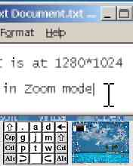

Magnify

Magnify is available in normal viewing mode (ie. not in Zoom mode) when using server-scaling or in Zoom mode when not using server scaling. When enabled the area under the current stylus location is displayed in magnified form, as below:

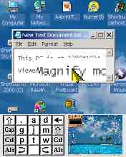

If no buttons are pressed the area will remain magnified for 5 seconds.

File Transfer

From the Connection menu you can opt to copy a file to or from the server.
Transferring a file is basically the same in either direction.
If you select “Copy file from server” then you will first see a screen like this:
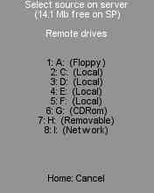

As you can see it will show the available drives on your PC.
To choose a drive simply press the appropriate button once to highlight it, again to select it and you will then view a directory of the drive:
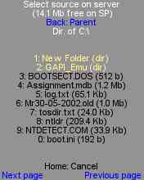

You can now browse to find the file you are looking for – also press once to highlight an option, again to select it.
Selecting a folder (in yellow) will take you to that folder’s directory, selecting a file will take you to the next stage of file transfer.
As you can see you can use the “back” button to go to parent and possibly the left and right menu buttons for next page and previous page.
Once you’ve selected a file you’ll now be able to browse for a destination:
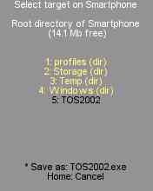

Browse in the same way until you have the required target, don’t worry if you wish to edit the destination filename, you can do that at the next stage.
Use * to highlight and select the “Save as” line to proceed to the filename edit stage:
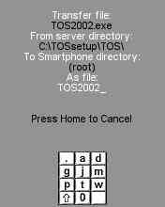

Use the keyboard to edit the filename (see page 13), then press enter (joypad centre).
If a file of the selected name & location exists already, you will get the following:
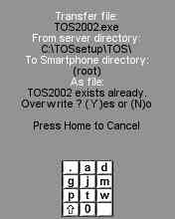

Press “y” to overwrite the file, “n” to change the name.

When you have entered the destination filename, file transfer will begin:
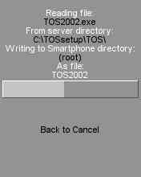

During file transfer you can abort by pressing the back button
When transfer is complete press the back button to continue.

Encodings/Settings

To reduce the bandwidth used, i.e. to reduce the amount of, and time taken for, data transfer, PTvncSWM5 has several encoding options available.
In the order of appearance these are:
Tight(+JPG), Zlib, Zlib Hextile, Hextile, CoRRE, RRE and Raw.
The best option in terms of bandwidth is Tight and the worst is Raw, however the best option in terms of server (PC) overhead is Raw and the worst is Tight so it’s down to your requirements as to which option is best for you (actually we found Tight and Zlib to be almost equivalent). If connecting to versions of RealVNC then “Tight”,” Zlib” and “Zlib Hextile” encodings are not supported (i.e. the server will use “RAW” format) so the optimum option considering speed/bandwidth is Hextile in this case.
Also to reduce bandwidth usage you can opt for using 8-bit RGB mode, which will result in some colour banding whereas the colours should look pretty much correct in 16-bit RGB mode. For those of you requiring low bandwidth usage 8-bit is probably the best option as generally speaking it doesn’t reduce the legibility of text but requires up to 50% less data transfer, however 16-bit using “Tight + JPG low quality” uses roughly the same bandwidth as 8-bit using “Tight” and may be preferable.
Further PTvncSWM5 also allows you to set the amount of server scaling (resizing of the screen) to be used before data transfer (with compatible WinVNC servers):
Optimum speed will request server reduction to the SMALLEST size >= 320*240 (or 240*320).
Optimum quality will request server reduction to the LARGEST size <= 640*512 (or 512*640).
High quality will request server reduction to the LARGEST size <=1280*1024 (or 1024*1280).
This results in the following scaling and screen transfer sizes:
PC resolution Optimum Speed Optimum Quality High Quality
640*480 (2) 320*240 (1) 640*480 (1) 640*480
800*600 (2) 400*300 (2) 400*300 (1) 800*600
1024*768 (3) 341*259 (2) 512*384 (1) 1024*768
1280*960 (4) 320*240 (2) 640*480 (1) 1280*960
1280*1024 (4) 320*256 (2) 640*512 (1) 1280*1024
1600*1200 (5) 320*240 (3) 533*400 (2) 800*600
When viewing in normal mode the pixels are displayed at the transfer size, in Zoom mode or under the Magnify when using server-scaling they are magnified *2.

Note that the screen buffer in PTvncSWM5 is 1280 Kilopixels (eg. 1280*1024 or 1024*1280) so when the WinVNC server does not support server scaling server screens larger than this cannot be handled by PTvncSWM5 (e.g. 1600*1200) – if using server-scaling then the server screen size does not present this problem.
Whether it be for speed of transfer/bandwidth usage or overhead on the PC it is best to have your PC in a resolution of 640*480 pixels with the PTvncSWM5 settings optimised for speed.
If you require one of the larger resolutions on your PC and wish to use server scaling but are having trouble reading the text on your Smartphone one option is to change your PC settings to use large fonts, either the PC standard option of 125% or a custom font size larger than this.
Note also that you will find the colour scheme used on your PC will have a direct bearing on the legibility of the PC text on your Smartphone – some colour combinations resample far better than others.
On some systems you may need to “enable loopback” in the advanced options of the WinVNC server (a symptom requiring this is “authentication failed” in PTvncSWM5).
If your PC’s network uses a router and you wish to connect to a WinVNC server remotely then you must ensure that the appropriate UDP port (5900 to 5909 or other) is being routed to the local IP address of the PC running WinVNC and that the router firewall is allowing data transfer through that port in both directions.
On the PC itself you need to ensure that any software firewall is also allowing data transfer in both directions through the appropriate port (5900 to 5909 or other).
At the time of writing you can check that your PC is open for VNC connection when running WinVNC (if using a port 5900-5909) by going here:
http://www.gotomyvnc.com/
Alternatively (at the time of writing) you can get your PCs remote IP address here:
http://www.whatismyip.com/
or here:
http://www.showmyip.com/
In rare cases your PC’s Internet Service Provider may be blocking UDP ports, if you think everything is set up correctly on the WinVNC end using a port 5900 to 5909 and “gotomyvnc” reports no connections open then contact your ISP (for the PC).
Some mobile ISP’s definitely block UDP ports, so if your PC is open but you can’t get PTvncSWM5 to connect remotely then check with your Smartphone’s ISP:
eg. T-Mobile (US) apparently restrict the ports available on a standard contract and one available is port 80 so in this case you would need a WinVNC server that allows selection of port 80 for connection (eg. UltraVNC).
Remember if connecting locally (eg. via Bluetooth) rather than remotely then you must use the local IP address of your PC (or the PC’s network name) and not the remote IP address.
If you’ve tried everything and still cannot connect but are using a VNC server other than PTeSVNC or UltraVNC then please try using WinVNC from PTeSVNC or UltraVNC.
If you cannot connect to WinVNC from PTeSVNC then you have a connection problem but if you can then there is a compatibility problem with the other VNC server.
If you require technical support for PTvncSWM5 go to:
http://www.parystec.demon.co.uk/pt_vnc_swm5.htm
for the latest info, FAQs etc.

or E-mail support@parystec.demon.co.uk

PTvncWM5 is available for Windows Mobile Pocket PCs and Pocket PC phones such as the Treo 700w.

